*Self-Help for Zombies:* 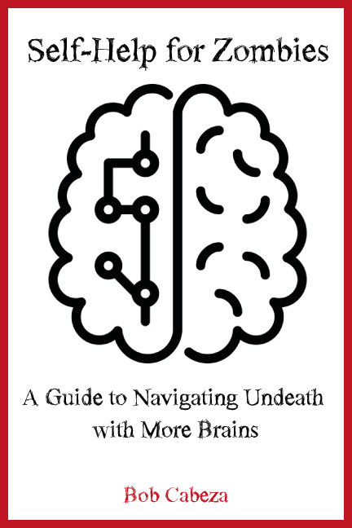

*A Guide to Navigating Undeath with More Brains*

By Bob Cabeza

**Publishing Date:** October 31, 2017

Trade Paperback Edition

**ISBN**: 978-1-123456-78-9

**RRP**: $15.95

**Binding**: 6x9 perfect paperback

**Page count:** 216 page extant (est.)

Transitioning to the afterlife isn’t for sissies—and when you’re not all the way dead, but definitely not alive, it’s even harder. Until now, there’s been no help for the newly raised undead other than inaccurate movies and the occasional advice column.

Every new zombie needs help navigating the complicated world out there. Will a head shot really send you to your ultimate end? Are human brains any better than, say, squirrel brains? How do you shuffle all day without developing a leg cramp? Can you manage the challenges of keeping up on the mortgage and still torment the living all night?

This revelatory new self-help book outlines all the key pain points for new “death-challenged” readers and frames the zombie experience in a bold new light.

Death is only the beginning!

*Trade Note*: Ideal for fans of John Romero and Stephen Covey, this book will help freshly turned readers have their best un-death experience.

**About the Author**

Bob Cabeza has been a writer for more than 35 years; he’s also been dead for 5. As one of the oldest zombies currently shambling the earth, Bob has learned the tips and tricks necessary to thrive in this new alternative lifestyle, from how to repair minor cuts and scratches to where to find the freshest sweetbreads and offal. He currently resides in Hell, Michigan, where he enjoys ice fishing.

**Press Contact:**

Bob Cabeza

666 Dead End Lane

Hell, Michigan 48169

441-666-1234

[bob@cabezawrites.com](mailto:bob@cabezawrites.com)